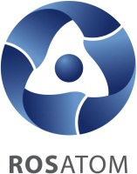
European Forum of Nuclear Industry Suppliers
ATOMEX-Europe 2013
as a part of Russian Business Day

Reminder for a Forum Delegate
Dear participants of the Forum ATOMEX-Europe!

Thank you for participation! We remind you that European Forum of Nuclear Industry Suppliers ATOMEX-Europe will take place October 08-09, 2013, in Brno, Czech Republic, Pavilion A, ROTUNDA Hall, Central European Exhibition Centre, BVV Veletrhy Brno, address: Výstaviště 1, CZ-647 00 Brno, CzechRepublic, tel.: +420 541 151 111.

The Forum is arranged as a part of Russian Business Day at the 55th International Mechanical-Engineering Exhibition MSV 2013.
Alongside with the Forum, a consolidated exhibition exposition of the State Corporation Rosatom will be presented at stand 027, pavilion Z, at the 55th exhibition MSV 2013 from October 7 to 11. We invite all Forum delegates to visit Rosatom’s exhibition stand.

Forum working hours:
October 08 – 09:30 through 17:00 ROTUNDA Hall, pavilion A
October 09 – 10:00 through 15:00 – Forum continues at Rosatom’s stand 027, pavilion Z.
The program offers a unique opportunity to take part in business meetings – face-to-face negotiations with the representatives of Russian organizations. Preliminary enrolment can be performed at the website nppsupply.com or at the Rosatom’s stand.

- Forum delegates registration:
October 09 – 9:00 through 9:30 at the registration box in the lobby of ROTUNDA Hall, pavilion A.
A welcoming coffee-break for forum delegates will be held October 08 from 09:00 to 09:30; subsequent coffee-breaks and lunches will be held as per the Forum Program.

- Drink reception on behalf of the State Corporation Rosatom on the occasion of the Forum closure is scheduled 14:00 October 09 at the exhibition stand of the State Corporation Rosatom, stand No. 027, pavilion Z.

Please note that the entrance to the exhibition complex is charged. You can purchase an entrance ticket in the box office at the entrance to the exhibition complex.

Please address the managers for prompt resolution of any issues:

Full name | Issues within responsibility | Contacts
Irina Kuramshina | Organizational issues on the participation in the Forum | + 7 905 528 86 62
Aziza Sitdikova | Organizational issues on the participation in the Forum | +7 963 674 29 42
Evgeny Yavdolyuk | Organizational issues on the participation in the Forum | + 7 963 674 34 82

The venue of holding the meeting:
Central European Exhibition Centre, BVV VeletrhyBrno, Výstavišt, 1, CZ-647 00 Brno, Czech Republic, tel.: +420 541 151 111

BVV Brno Exhibition Centre Masterplan

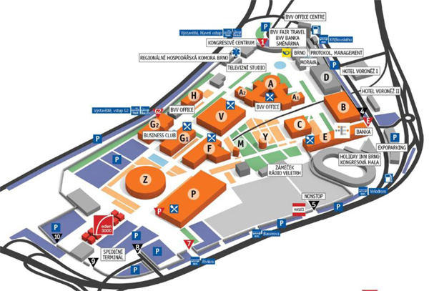

Wish you successful work at the Forum!

